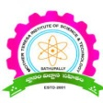 | MOTHER TERESA INSTITUTE OF SCIENCE & TECHNOLOGY  Sathupally, Khammam Dist., Telangana

DEPARTMENT OF ELECTRONICS AND COMMUNICATION ENGINEERING
ACADEMIC YEAR: 2020-21
A SUMMARY REPORT
A Boot Camp on “Python Programming”

A Two-Week National Level Workshop on “Python Programming”
From 06.12.2021 to 20.12.2021

Topic: Python Programming
Name of the Resource Person: Mr.P.Guru Prasad, SAK Informatics, Hyderabad
No. of Students attended: 37
Summary:
During the Day the Boot Camp Mr.P.Guru Prasad, SAK Informatics, Hyderabad covered the python programming with the following content:

Introduction to python programming,

Characteristics of Python,

Applications Based on Python
Web applications, Web frameworks,
Software development,
Graphic user interface applications,

Prototyping, Operating Systems,

Applications (Business and Enterprise).

Advantages and Disadvantages of Python

Basic Python Commands, Basic main function

Python Identifiers

Data Manipulation Methods with Python

Raising Exceptions, User-Defined Exceptions

Frameworks of Python, Function Overloading in Python

Benefits of Python for Database Programming

Conditional Statement in Python

Meanwhile photo session was arranged with the resource person, students and with Programme organizing committee

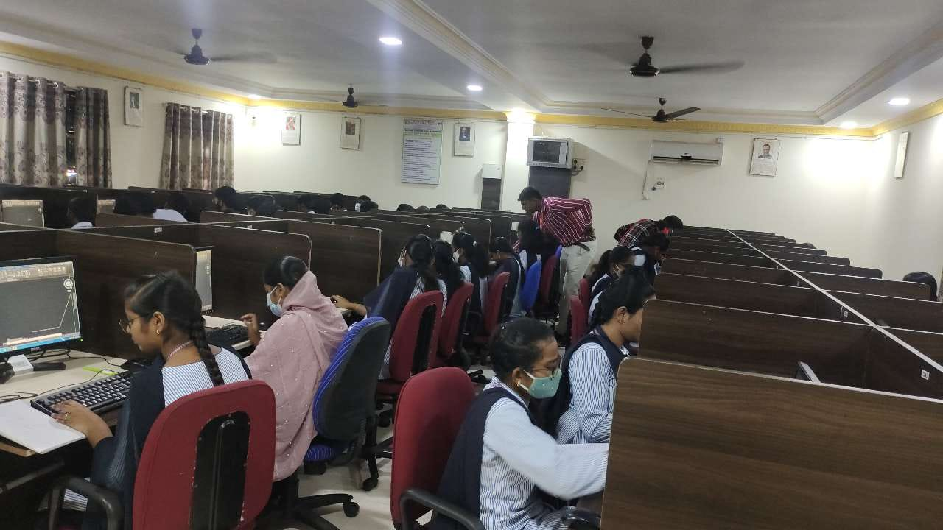

The valedictory session started with getting feedback from the participants about the workshop by Mr.P.Guru Prasad, SAK Informatics, Then Shaik Samreen delivered the vote of thanks for the participants and for the Resource person.

Prepared by Coordinator HOD/ECE

